**A Project Report**

**ON**

# “Hospital Management System”

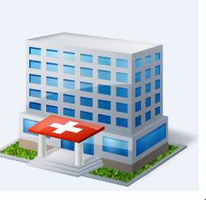

**Academic Year**

**2021-2022**

**Developed By**

**Gorasiya Prinsi**

**Savaliya Ritika**

**Under the Guidance of**

**Bharat Sir**

**Affiliated with Saurashtra University**

**SHREE SAURASTRA COLLAGE OF**

**MANAGEMENT AND COMPUTER SCIENCE**

**(Managed by: Sardar Patel Sankul)**

**Opp.Bhoomi Ginning, Atkot-jasdan Highway,Atkot-360040**

## CERTIFICATE

This is certify that Gorasiya Prinsi And Savaliya Ritika with seat no ___________ is a final year student of the Bachelor Of Computer Application (BCA) Saurashtra University, and is required to do a six month BCA project work in his/her Five Semester. The experience gained by this project work, not only benefit the student to partially fulfil the requirement of the BCA of Saurashtra University, but also lay a foundation for his/her future career.

**H.O.D.**  **Signature of principal**

Bharat sir Shree Saurashtra

Shree Saurashtra Collage of

Collage of Mgt.& Comp.Science

Mgt.& Comp.Science

**ACKNOWLEDGEMENT**

We take this opportunity to express our gratitude to our guide, Bharat Sir a computer department , Project Guide for their valuable guidance and continual encourage us through out the project. We are heartily thankful to him for his time-to-time suggestion and clarifying the concepts of the topic that helped us a lot during the development of the project, for his help getting a better understanding of the project domain, solving problems encountered during project implementation as well as project testing, and for his precious suggestion for the project, through his experience in project development.

We special thanks to our family members for the moral support given through out our study, Above all we offered. We heartiest regards to “GOD” for given us strength work inspiration.

**Thank You......**

**Abstract**

Hospital was developed following system development stages for smooth running and management of Hospital. The Few months provided by the Saurashtra University examination enabled the system analyst recognize and define the problem in the current manual system. After an information gathering process from several Hospital managed by manual and computerized systems, the system analyst saw that the Hospital Management indeed needed a computerized management system.

The system was developed using visual studio for applications (Microsoft SQL Server) language. This system will indeed help the Hospital Management and the manage and steer the functionality and transactions to realize its maximum potential in addition to its competence in the Hospital.

Index

No. Particulars Page no.

1. Introduction 8

1.1Introduction of our Website

1.2 Purpose

1.3 Scope

**2.** System Analysis 9

2.1 Analysis of current system

3. System Requirement Analysis 10

3.1 User Characteristics

3.2 Hardware and software requirements

4. Project Management 12

4.1 Project Mode

5. Feasibility Analysis 13

5.1 Technical Feasibility

5.2 Operational Feasibility

5.3 Economical Feasibility

6. System and database Design 15

6.1 Database Design

6.2 Flow Chart

6.3 E-R Diagram

6.4 Data Flow Diagram

6.5 Use Case Diagram

7. Screenshots 24

8. Project Limitation sand Feature Enhancement 40

9. Testing 41

10. Project Conclusion 42

11. Referance 43

**Project Profile**

* **Project Title :** Library Management System
* **Organization :** MatuShri SantokBaa Medical Center
* **Front End Tool :** Microsoft Visual Studio 2010
* **Back End Tool :** Microsoft SQL server 2008
* **Operating System :** Microsoft Window 7
* **Project Team Size :** Two
* **Duration :** Two Month
* **Developed By :** Gorasiya Prinsi

Savaliya Ritika

####  Project Guide : Bharat Sir

* **Hardware User :** Intel(R) Pentiums(R) Processor

4-GB OF RAM

* **Submitted :** Shree Saurashtra Collage of Mgt.&Comp.

Science, Atkot

**1.Introduction**

### 1.1 Introduction of our Website

We are making the Website which title is “Hospital Management System”. We made this website for the “MatuShri Santokba Medicical Center” .

#### 1.2 Purpose

MatuShri Santokba Hospital is a best medicity. Well equipped With modern apparatus. All type of treatment and investigations are provided free of charged for at minimum of rates. MatuShri Santokba Hospital is a public hospital located in Lathi, Gujarat.

#### 1.3 Project Scope

User Friendly Website

Users have to register to enter the Project.

We Provide…..

* Best Treatment
* Embulace Service
* Emergency Service
* Blood Bank

## 2.System Analysis

### 2.1 Analysis of current system

First of all we take a visit of the Hospital. And visit the Matushri SantokBaa Medical Center. He gave the information about the Hospital Management and different Types of work that has been doing in Hospital .

* In that time mostly all the persons show all the things in Website.
* Because in that modern time all the things are available in Website so no need to purchase it from market.

### 2.2 Analysis of existing system

System analysis is a detailed study of the various operations performed by a system and their relationships within and outside of the system. Here the key question is what all problems exist in the present system? What must be done to solve the problem? Analysis begins when a user or manager begins a study of the program using existing system.

**System analysis can be categorized into four parts:**

 System Planning and initial investigation.

 Information Gathering.

 Applying analysis tools for structured analysis.

 Cost/Benefit analysis.

## 3. System Requirement Analysis

### 3.1 User Characteristic

* User must have knowledge of computer system.
* He must able to remember his username and password.
* He must have knowledge of this system and its functionalities.
* He must have to know how to access Asp.Net.

### 3.2 Hardware, Software requirement

During this phase of SDLC, one has to enlist the configuration of hardware and support software essential to execute the specified application

#### Hardware & Software Specification:-

|  |  |  |
| --- | --- | --- |
| **Category** | **Hardware** | **Software** |
| **Processor** | Pentium (R) or latest version | Pentium (R) or latest version |
| **Hard Disk Drive** | 40 GB or Higher | 20 GB or Higher |
| **RAM** | 256 MB or Higher | 64GB or Higher |
| **Floppy Disk Drive** | 1.44 MB or Higher | 1.44GB or Higher |
| **Monitor** | 14’’ Color or higher | 14” color |
| **Network Devices** | Network Adapter | Network Adapter |

#### 

#### Software Requirements:-

|  |  |  |
| --- | --- | --- |
| **No.** | **Software Used** | **Remarks** |
| 1 | SQL server 2008 | Used as the Back End for the system. It holds the entire database. |
| 2 | Microsoft Visual Studio 2010 | It is the technology Used as the Scripting language |
| 3 | Any Network Operating System | Used on the client side |

## 4. Project Management

### 4.1 Project Model

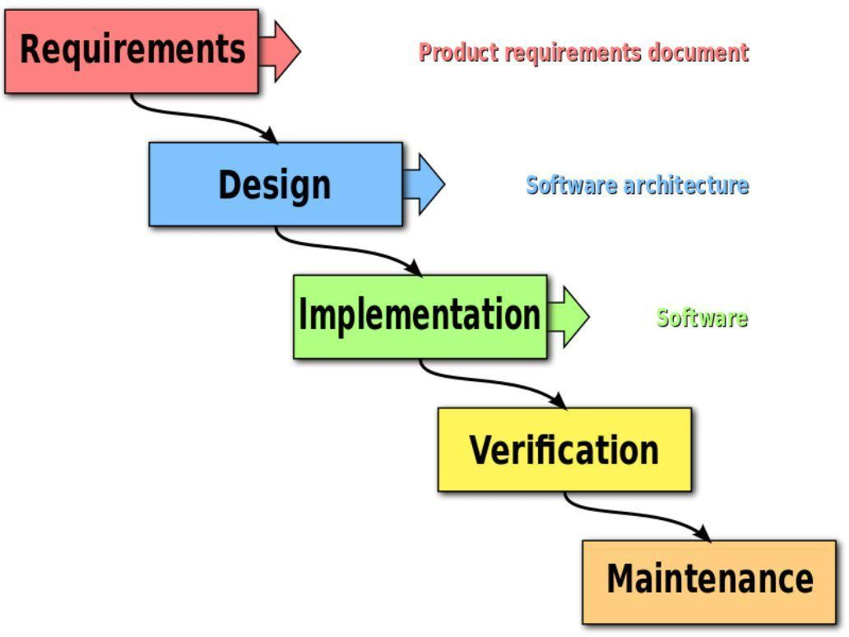

### 

### 5. Feasibility Analysis

Feasibility of the project determines whether it is possible to develop the project or not. There are 3 main factors, which determine the feasibility of the project. They are discussed as follow:-

* *Technical Feasibility*
* *Economical Feasibility*
* *Operational Feasibility*

  

#### 5.1 Technical Feasibility :-

The technical feasibility takes into consideration the technical requirement and their availability in the market. It determines whether it is possible to develop the proposed system with the present technology or not. The technical possibilities of present system are as follows:-

* *The hardware is currently being used by the company.*
* *Proposed system doesn’t require any technical details.*
* *It needs low configuration computer system.*
* *The technical specification is easy available in the market.*

#### 5.2 Economical Feasibility :-

|  |  |  |  |  |
| --- | --- | --- | --- | --- |
| **No.** | **Software** | **Requirement** | **Max** | **Price** |
| 1 | OS | Windows 7 | Windows 7 | 10580 |
| 2 | Hard disk | Free space upto  20 GB | 150 GB | 1490 |

3 C# & SQL 1 GB 1.5 GB 15000

#### 5.3 Operational Feasibility :-

The operational feasibility deals with the matter whether the proposed system fulfils the requirement of the firm. This feasibility determines whether the proposed system covers all the aspect of the current system. The possibility of the operational feasibility is as follows:-

* *The proposed system will fulfill the firms’ requirement.*
* *The proposed system covers all the aspect of the working system.*
* *The expected users of the proposed system are honestly eager for the new system.*
* *The changes made in this system are quite beneficially.*

**6. System and Database Design**

#### 6.1 Database Design :-

The Following are the designs of the tables that shall be used to store the data in the system.

**User Master**

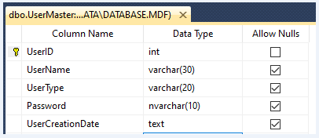

**Client Registration**

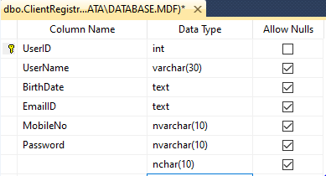

**Patient Registration**

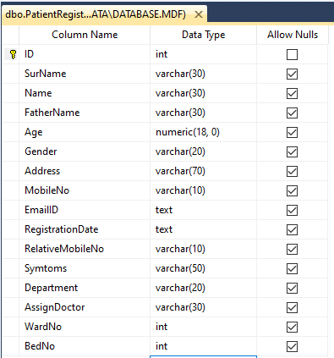

**Doctor Master**

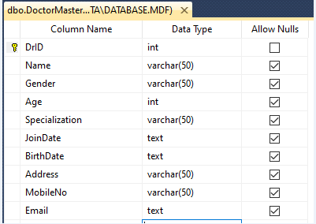

**Discharge Master**

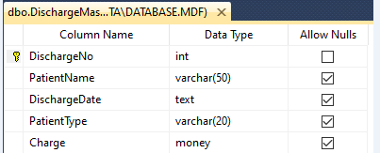

#### 

**Ward Master**

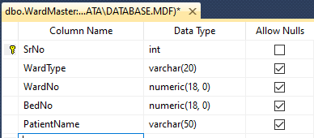

**Medicine Master**

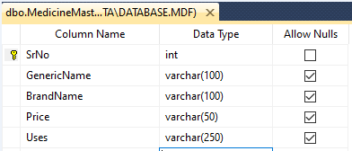

**FeedBack**

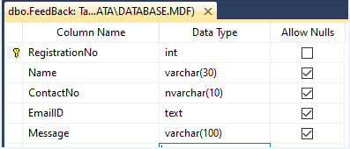

#### 

## 6.2 Flow Chart

**Home**

**Admin**

**Client**

**Login**

**Registration**

**Client Panel**

**Admin Panel**

**Reports**

**FeedBack**

**Discharge Master**

**Medicine Master**

**Ward Master**

**Home**

**User Master**

**Doctor Master**

**In-Patient Master**

**Out-Patient Master**

**FeedBack**

**About Us**

**Contact Us**

**Doctor Details**

**Medicine Master**

**Home**

**Patient Registration**

#### 

## 6.3 E-R Diagram

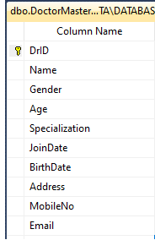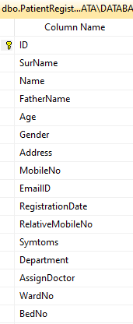 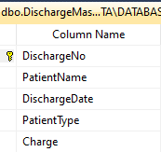

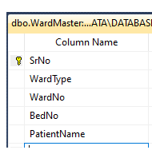 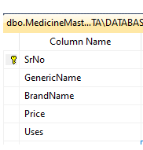

6.4 Data Flow Diagram

Represent data flow

Represent a Form

Represent a data table

Represent a Report

Represent a Processing

**Login**

**LMS**

**Registration**

**Feedback**

**Discharge Master**

**Medicine Master**

**Ward Master**

**Out-Patient Master**

**Ward Master**

**In-Patient Master**

**Doctor Master**

**User Master**

**Home**

**Admin Panel**

**Client Panel**

**Doctor Details**

**Contact Us**

**FeedBack**

**Patient Registration**

**About Us**

**Medical Master**

**Report**

**Logout**

## 6.5 UseCase Diagram

**User**

## 

7.Screenshot

## 

## Home

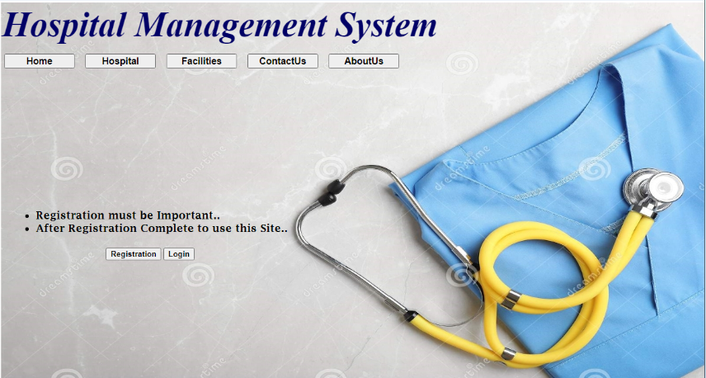

## Registration

## 

## Login

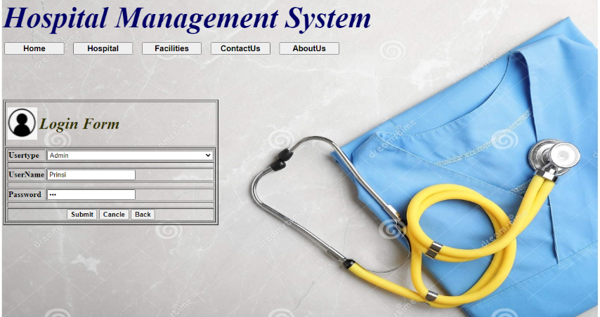

## Gelery

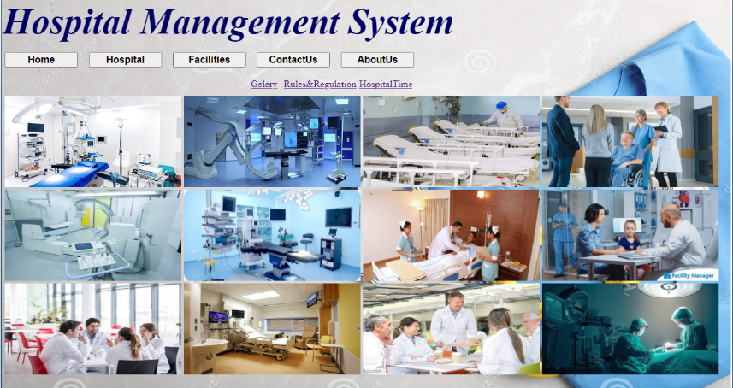

## Rules&Regulation

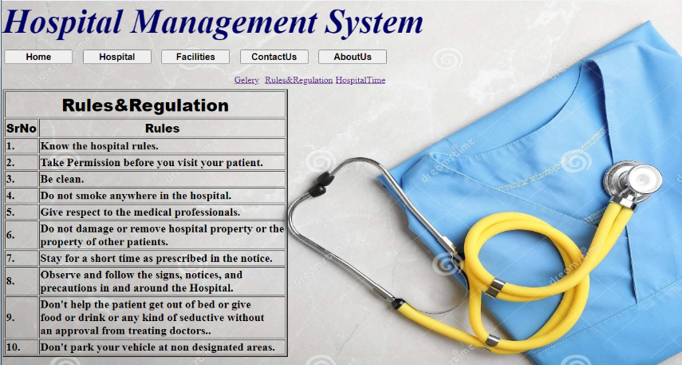

## Hospital Time

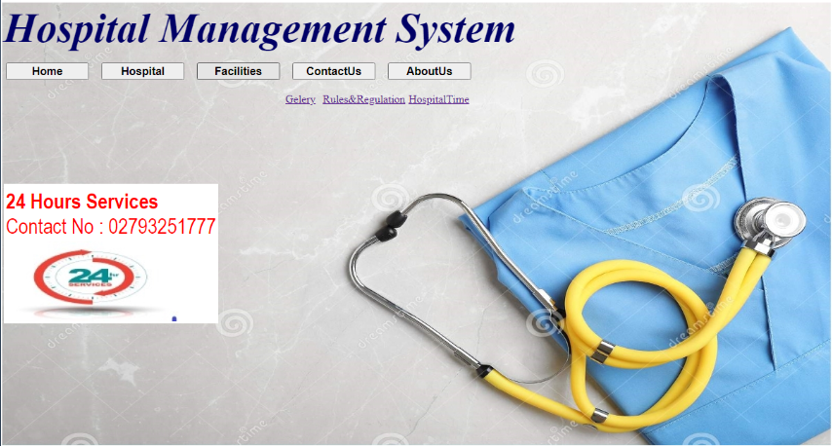

## Facilities

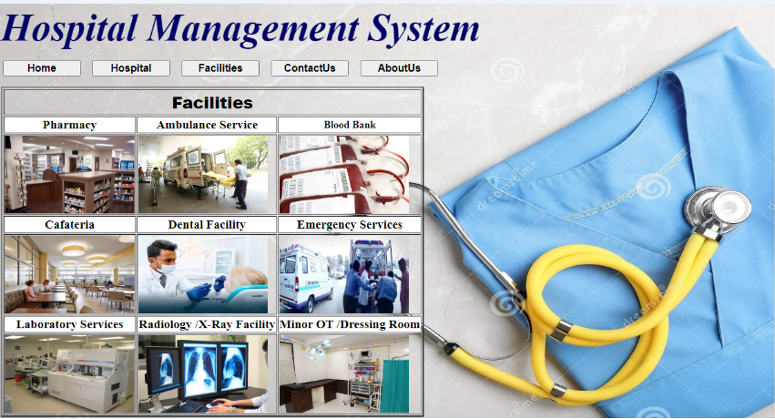

## Contact Us

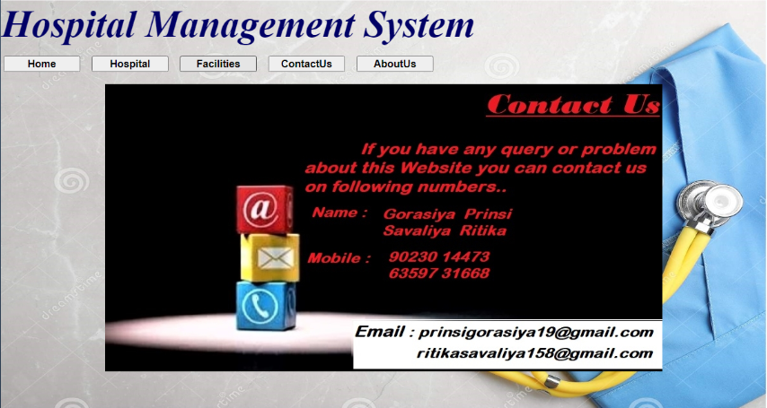

## About Us

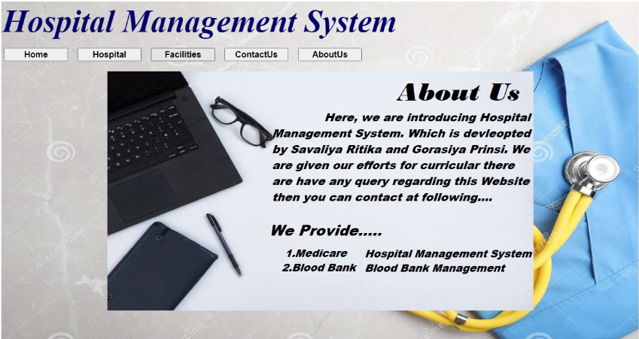

Client Panel

## Home

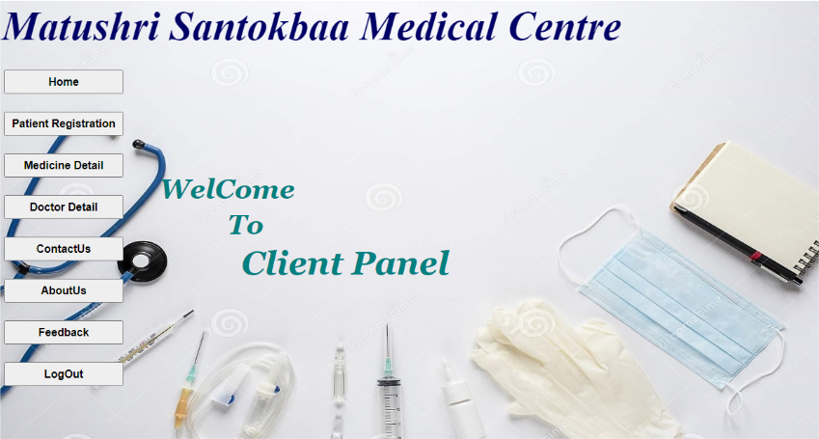

## Patient Registration

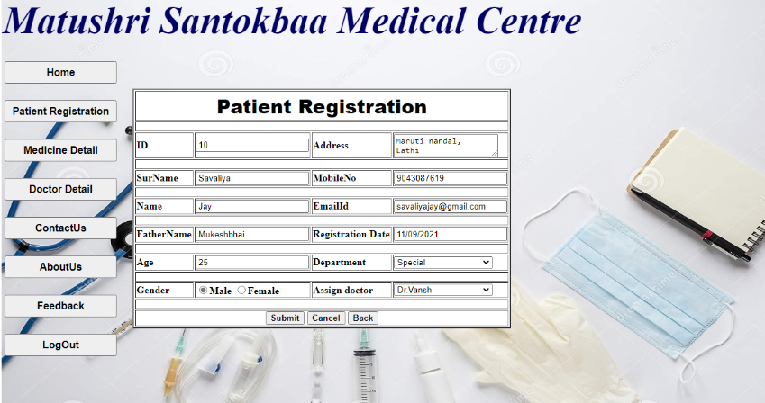

## Medicine Details

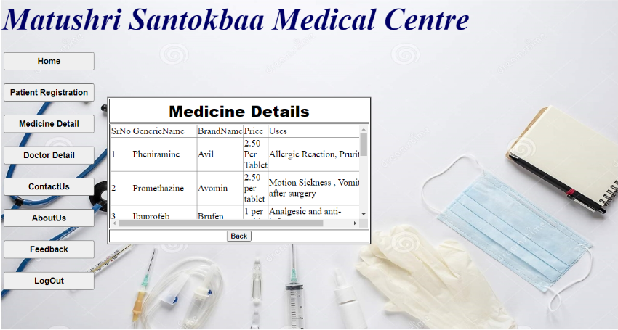

## Doctor Details

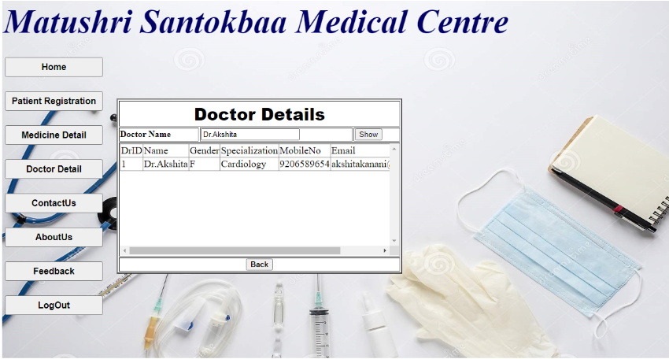

## Contact Us

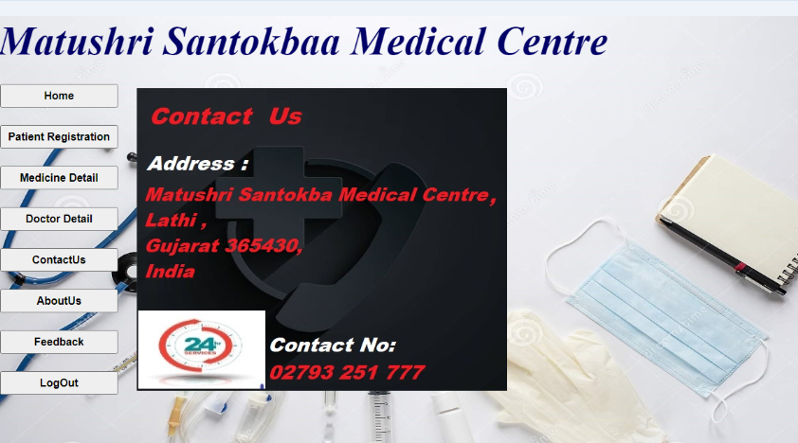

## About Us

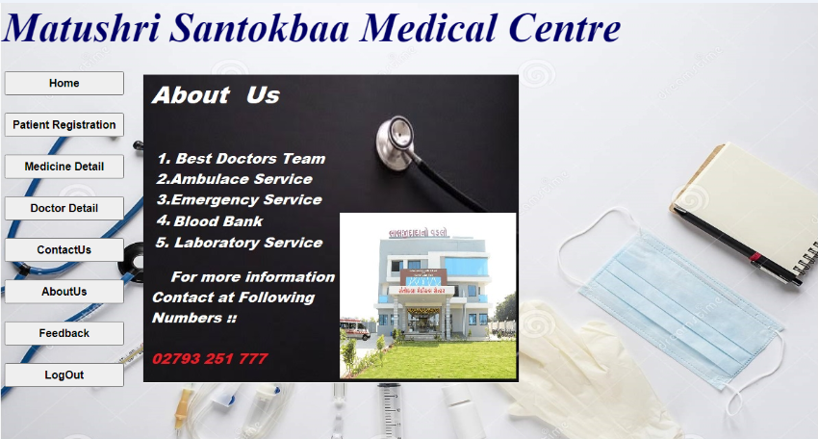

## FeedBack

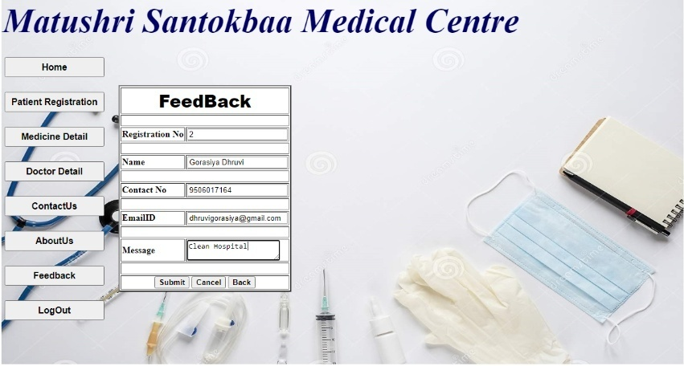

Admin Panel

## Home

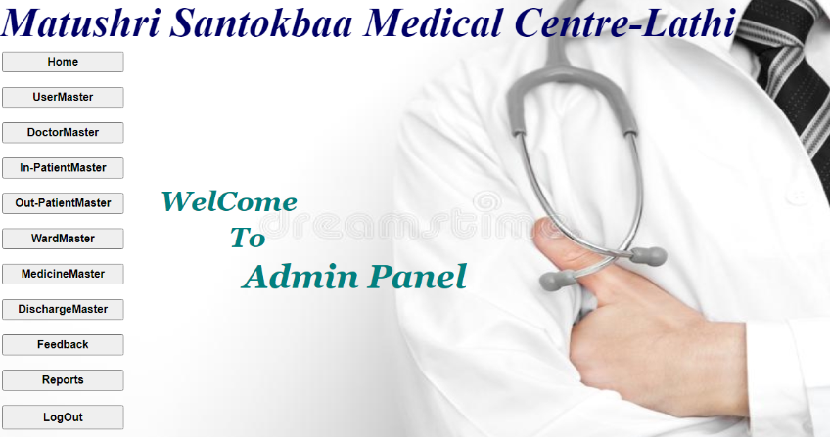

## User Master

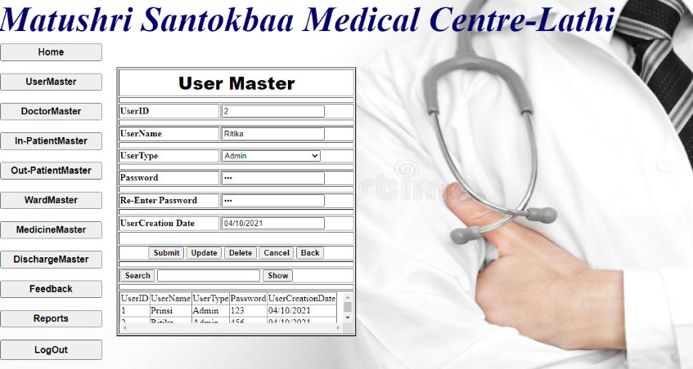

## Doctor Master

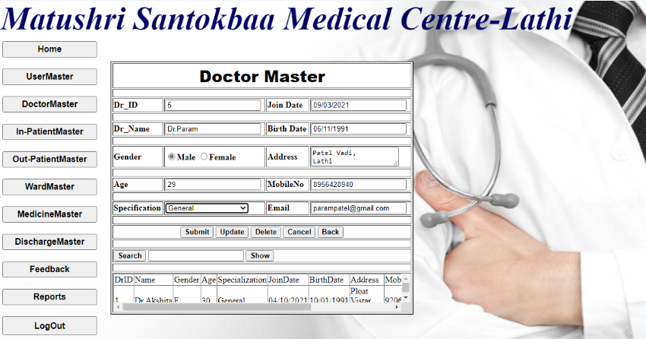

## In-Patient Master

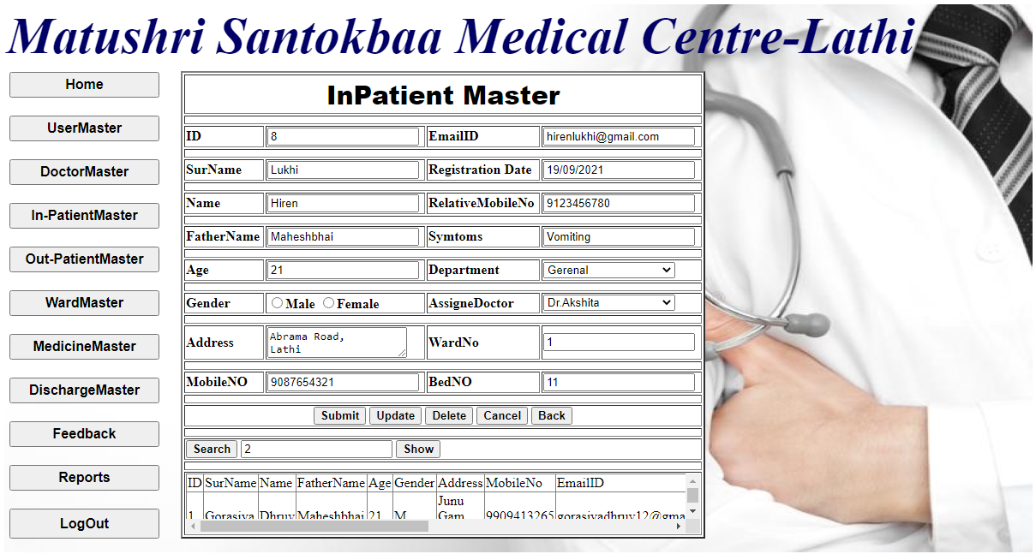

## Out-Patient Master

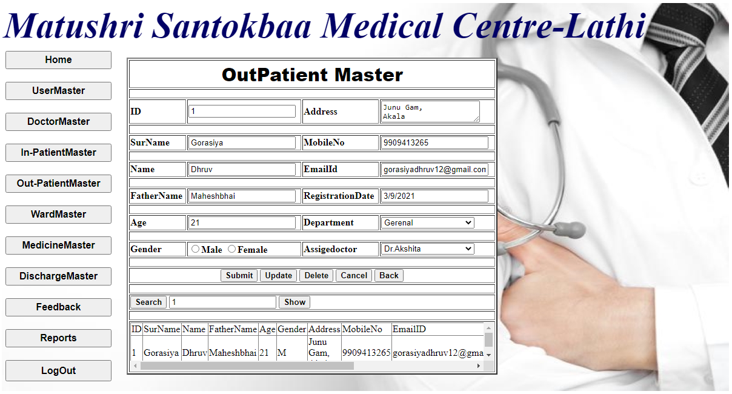

## Ward Master

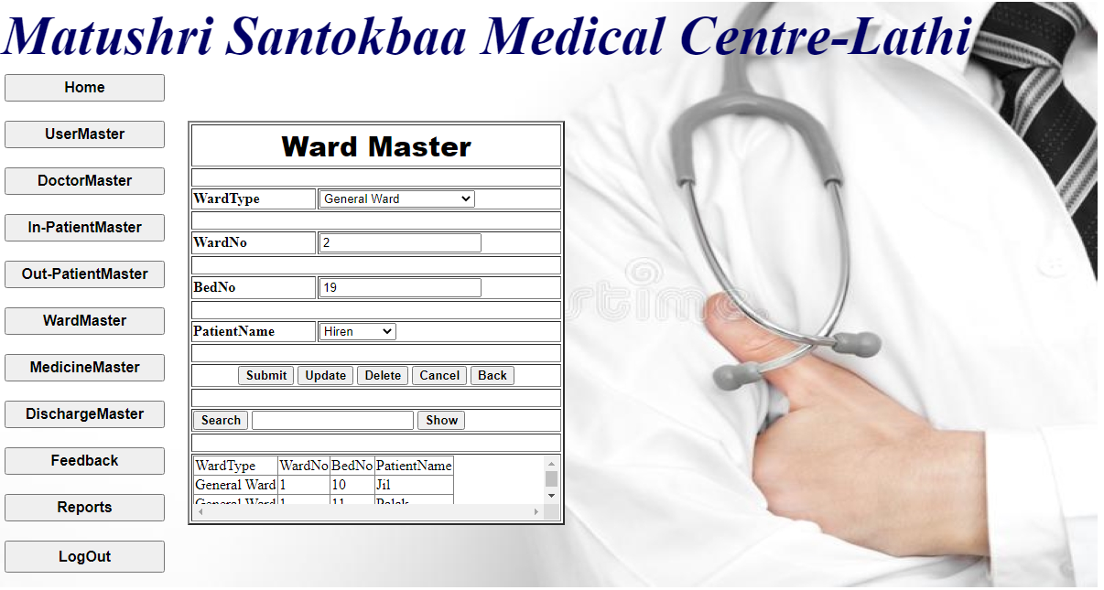

## Medicine Master

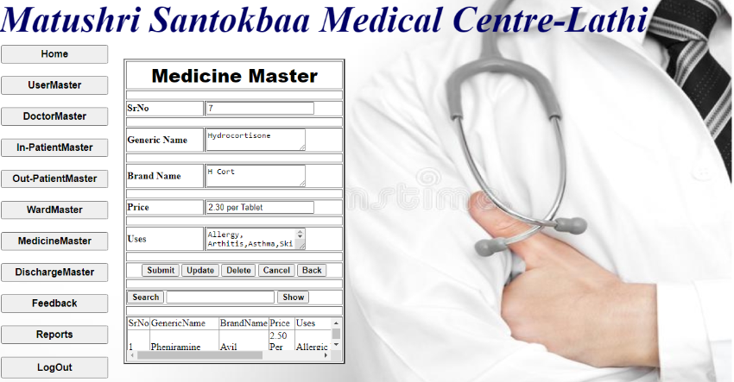

## Discharge Master

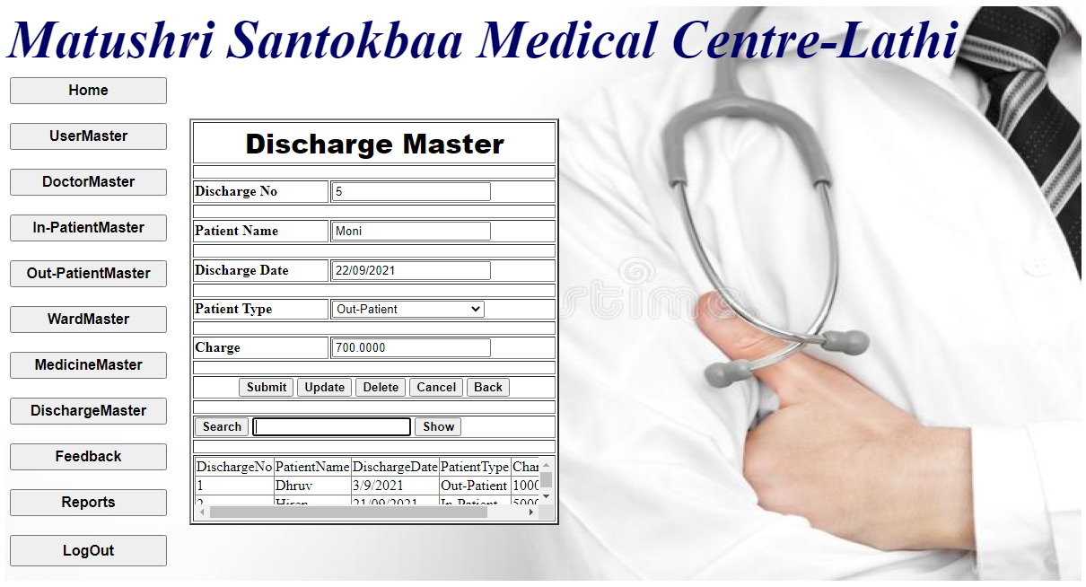

## FeedBack

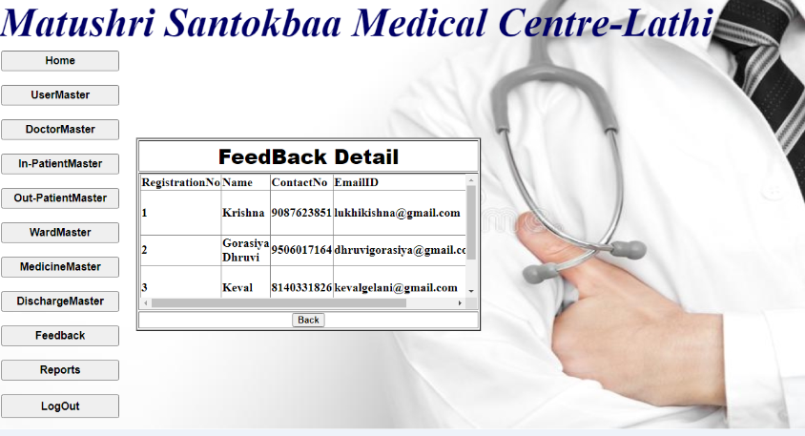

## Reports

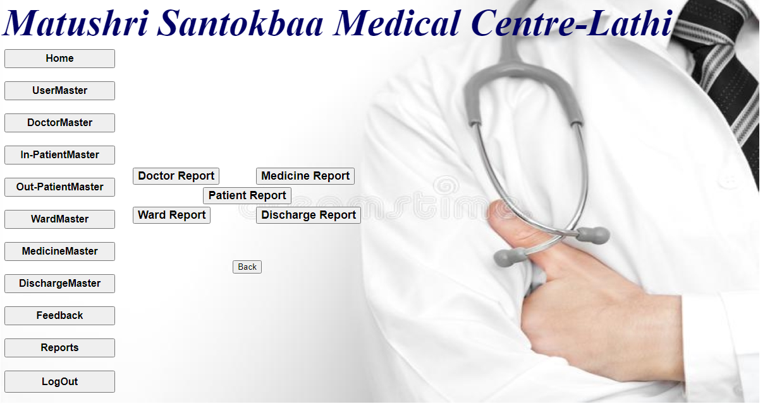

## Doctor Report

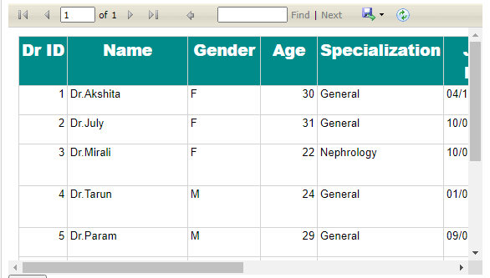

## Medicine Report

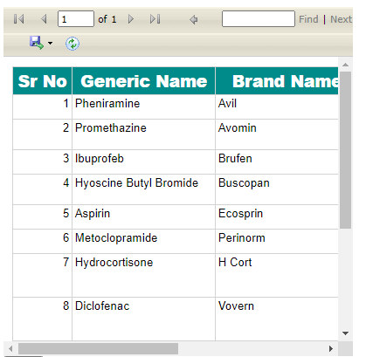

## Ward Report

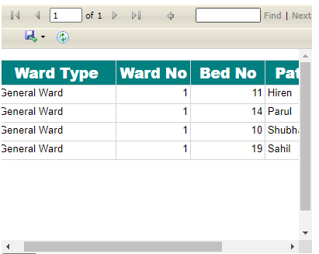

## Patient Report

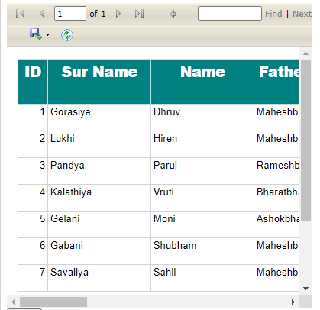

## Discharge Report

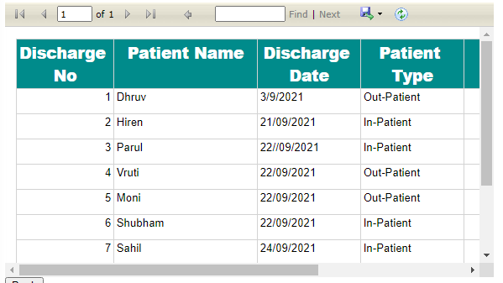

8. Project Limitation & Features

* **Advantage Of Project**
* This Website is on computer based so the user must have Knowledge about computer system and Asp.net.
* User can not do any changes itself in coding.
* In future it must have changes in requirement so it might be having big changes in coding.
* **Limitation Of Project**

* The computer needs continuously electricity in case of power failure.
* All works is to be done manually.
* Speed depends on the computer RAM or processor. ϖ
* Server can be overloaded.
* The student can not be registered online

### 9. Testing

#### Black Box-Testing:-

Black box testing assume the code to be a black box that resourced to input Stimuli. The testing focuses on the output to various of types of stimuli in The targeted deployment environments . It focuses on validation tests , boundary ,condition, destructive testing , reproducibility tests, performance tests, globalization, And security-related testing..

**The following input is required for black box testing:**

* Requirements
* Functional
* Specification
* High-level design
* Document
* Application block source code

#### White Box-Testing:-

White box testing assumes that the tester can take a look at the code for the application block and create test cases that look for any potential failure scenarios. During white box testing, you analyze the code of the application block and prepare test cases for testing the functionality to ensure that the class is behaving in accordance with the specifications and testing for robustness.

### 10. Conclusion

With the permission from Saurashtra university, To develop a system that would computerize the books an article. The system analyst has been able to come to a successfully access.

As he concludes, he is grateful that the system will be able to server it’s intended purpose an meet it’s objectives to the satisfaction of the library management.

In this short document I have tried to cover most of the areas of concern in writing a project report. Naturally, this is not the last word on the subject. If you have time, you should have a look at one or more of the books recommended in the references and bibliography.

### 11. Reference

#### A. Website Name:-

1. [**www.google.com**](http://www.google.com/)

1. **monarch_computer@rediffmail.com**

#### B. Reference :-

➢ **Complete reference (ASP.NET)**

##### ➢ **ASP.NET 4.0 PROGRAMMING**

